# Exp 5a – File Listing & Details

# Program:

echo "Current Files List"

echo "--------------------------"

ls *.sh

echo "Enter File Name"

read filename

if [ -f $filename ]

then

res=`ls -li | grep $filename`

set -- $res

echo ""

echo " Details of File $filename"

echo "----------------------------------"

echo "| Inode Number : $1"

echo "| File Permissions : $2"

echo "| Links : $3"

echo "| File Owner : $4"

echo "| File Permissions : $5"

echo "| Number of Words : $6"

echo "| Last Date Modified : $7 $8"

echo "| Last Time Modified : $9"

echo "----------------------------------"

else

echo "else part"

fi

# Output:

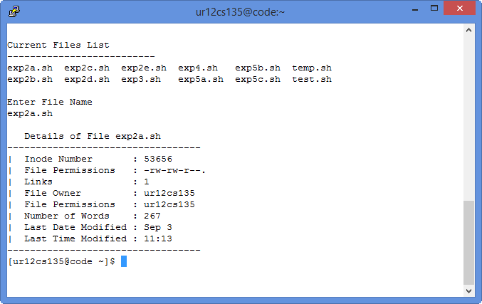

# Exp 5b – System User Details

# Program:

clear

echo "Enter System User"

read user

echo ""

echo "----------------------"

echo "User id :"

grep "$user" /etc/passwd | cut -d ":" -f 3

echo "User Directory :"

grep "$user" /etc/passwd | cut -d ":" -f 1

echo "User Default Shell:"

grep "$user" /etc/passwd | cut -d ":" -f 7

echo "----------------------"

echo ""

echo "Enter 1 Display your Username Details"

read option

if [ $option == 1 ]

then

echo "Enter your Username"

read uid

`getent passwd $uid`

fi

# Output:

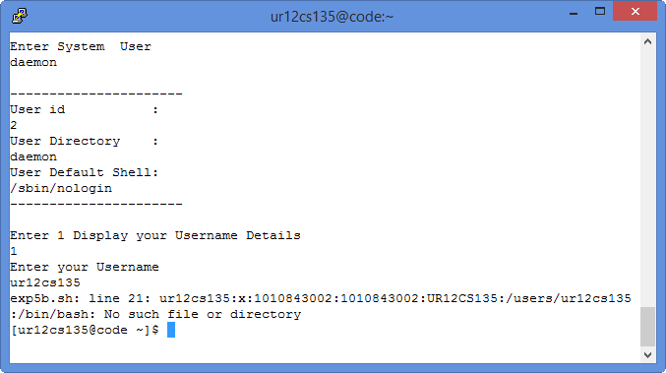

# Exp 5c – Word Count for character and word in a File

# Program:

echo ""

echo " File Search"

echo "---------------------------"

echo ""

echo "Enter Filename"

read file

echo "Enter a Character to give the count of its repatition"

read a

echo "Enter a word to give the count of its repetitions"

read word

echo ""

echo ""

echo "Content in File"

echo "--------------------------------------------------"

echo ""

cat $file

echo ""

echo "--------------------------------------------------"

echo ""

echo -n "Count of the Character : "

grep -o "$a" $file | wc -l

echo -n "Count of the Word : "

grep -o "$word" $file | wc -l

echo ""

# Output:

